**CAN IRREGULAR PERIODS AFFECT FERTILITY?**

Every woman dreams to get married to someone having a nice family background and taking the legacy forward and make a nice happy family themselves. But some complications in the act can lead to break this dream. No! Not completely but to certain limits. To make sure and conceive safely, some points must be noted on time.

**Do irregular periods affect my ability to get pregnant?**

No, not completely and Yes, to some extents. Irregular periods would simply mean an irregular health schedule consisting of irrational diets and habits that needs to be completely removed from the scenario. But how can irregular periods affect fertility? Let’s have a look.

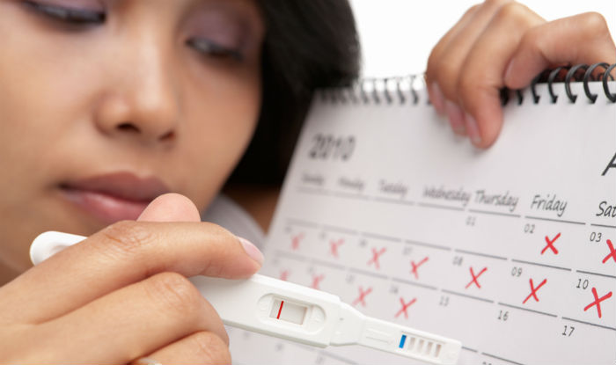

**Irregular periods**

What are irregular periods? Is there any risk in having irregular periods? Let’s find out! Irregular periods are symptoms of either having an unhealthy body or unhealthy functioning of ovaries that causes ovulation.

Our body ovulates i.e. produces eggs, which when fused with sperms forms zygote that eventually takes warmth, food and care from mother’s womb and turns into a baby. Now, the uterus lining makes a sac-like structure using blood vessels to keep the baby shelled. If one of the eggs get fertilized, this uterus lining remains in the woman’s womb. If eggs are not fertilized, this uterus lining breaks and causes menstruation.

‘Irregular periods’ is a term given to either having delayed periods with a time-gap of 35 days or experiencing periods in a time-gap of just 21 days! It also includes conditions such as having an extremely heavy periods for around 8 days in a month and periods for only 3 days in the following month.

**Some other causes of irregular periods** to answer: Can irregular periods affect fertility?

* Taking birth control pills or other meds

Medicines relieve us from unwanted symptoms of any disease that causes problems. But some might have side effects. Birth control pills kill the eggs produced by ovary. No eggs mean no fusion with sperms and no pregnancy. These can have a side effect when we might wish to get pregnancy.

* Too much exercise can lead to irregular periods

Because of stressful long-term exercising, ovulation process decreases leading to infertility.

* Pregnancy with PCOS

Sometimes, the cause of irregular periods might be due to PCOS (Polycystic Ovary Syndrome) i.e. formation of cysts and leading to swollen ovary making it hard to ovulate.

* Thickness of uterus lining

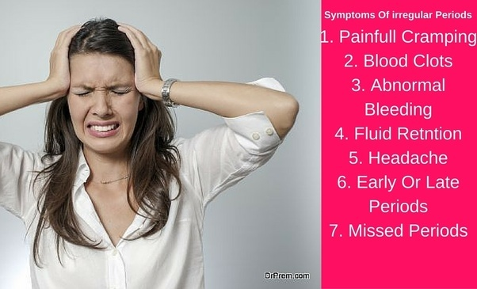During periods, the blood vessels might not completely break resulting in thickening of uterus lining interrupting in expected pregnancy. And this shows how can irregular periods affect fertility.

**Steps to confirm pregnancy with irregular periods**

Every destination comprises of loop rules to follow. Pregnancy is the most important stage of a woman’s life and she’s most delicate and fragile while pregnant. Every step in pregnancy is taken with utmost care. While getting pregnant with irregular periods, the attention and support needs to be doubled to achieve a successful conceiving time. Confirm pregnancy and demolish “how can irregular periods affect fertility” search form your life as it won’t disturb you any longer!

**Confirm pregnancy with irregular periods by:**

* Time of ovulation must be recorded via several available devices or by consulting doctors. A healthy ovulation occurs 12 to 14 days before getting next periods. For irregular periods, ovulation time might get increased or decreased accordingly. A woman having less periods (less than 3 days) ovulates more than a woman with normal period cycle while a woman having an extended or late period cycle tends to ovulate less than a normal period cycle. How can irregular periods affect fertility? Read next!
* You might also confirm pregnancy with irregular periods by taking fertility drugs readily available. But they must be cross-checked twice from a known doctor according to health routines. They boost up process of ovulation. Have sex in the meantime and happy news will knock your door soon! How can irregular periods affect fertility? Go on!
* Major changes in hormone secretion (here, estrogen and progesterone) may lead to infertility too. Having their levels checked and taking corresponding medication can help fixing the infertility productively. How can irregular periods affect fertility? Continue!
* With irregular periods, time shift in ovulation is accompanied. Getting pregnant with irregular periods or regular ones just after periods is a rare case. Involve yourself in more sexual intercourses during expected ovulation time. This will reduce periods-related stress and obviously a fun time with your partner! How can irregular periods affect fertility? Here we go!

Starting from puberty to menopause, I, being a woman, have witnessed several hormonal changes that has affected my sexual appearances as well as body activities. Irregular periods affect my ability to get pregnant but I surely can help myself by taking various measures.

“Can irregular periods affect fertility? It surely can but it doesn’t have the full control over my body!” I am the one who have full right to change what’s happening and mould it my way.

**Short tips to encounter healthy periods**

* Improve your eating habits.
* If obese, start exercising (preferably yoga).
* If underweight, start taking healthy diet.
* Say bye-bye to stress causing activities and people.
* Make healthy emotional relationship.
* If anaemia-stricken, take sufficient iron supplements.
* Stay happy!
* Stay hydrated. Drink enough water.



**What to avoid?**

* Increased exercising and weight lifting.
* Smoking
* Alcohol and caffeine drinks
* Traveling
* And birth control pills

If you take medication for any other cause, make sure it is free from any birth control pills. Also, minor irregularities in periods can be avoided. It is not necessary that you are infertile taking into consideration only 2-3 months of period cycle. This reduces the ‘can irregular periods affect fertility’ effect.

If you are having sex at regular intervals (3-4 times a week), you need not to worry about missing ovulation.

Exercising proves to be very benefitting. A regular of one or half an hour exercising can do miracles! It helps in activating body cells in human body that aren’t involved in daily tight schedules. Increasing the miracle list, exercising opens up blood vessels (add-ons for a woman having irregular periods) and if done in morning can become a reason of your fresh and energetic change!

**When can irregular periods affect fertility?**

Simply, when a woman takes uncontrollable amounts of non-recommended diets or live a carefree life not even taking enough care to carry healthy organs with them!

**What happens after getting pregnant with irregular periods?**

Irregular periods are a door leading to distorted roads. Irregular periods affect my ability to get pregnant and if I know I am already pregnant, special care must be taken. Getting pregnant with irregular periods increases chances of miscarriage because a weak womb won’t be able to handle a baby for long.

**Symptoms of pregnancy with irregular periods**

* Breast tenderness
* Leakage through nipples
* Cramps in the lower abdomen
* Headaches
* Increased tiredness
* Emotional stress
* Frequent mood swings

Now you know how can irregular periods affect fertility and to what extent you can control the effects. If you are getting pregnant with irregular periods, check for the above-mentioned symptoms and if found positive and getting negative pregnancy results, talk to your doctor and take pregnancy tests consistently without loosing hope. It might turn out to be a ‘false negative’ condition. So, how can irregular periods affect fertility if we take care of the symptoms and act before they can interrupt! Keep experimenting and don’t loose hope. After all, evolutions don’t occur in a day!